Mission Hills High School
Visual and Performing Arts
Dance
Courses Offered:
Dance One Our beginning dance class is perfect for beginners, but challenging enough for
experienced dancers. Basic dance in various styles will be introduced through
choreography, technique, and performance skills. Performance opportunities will
be given in our winter and spring shows. This class can be taken for PE credit!

Dance Two This class is designed for students that have taken Dance One, or have dance
experience and audition into this class. Several performance opportunities are
produced each year. Students will train in technique, choreography skills, create
dances of their own, and work with professional guest artists.

Dance Production This is for our experienced dancers that audition into this class. They
will train in everything Dance Two experiences, but will have the
opportunity to perform in additional advanced repertory pieces with
select casts and guest choreographers. This class also will produce a
dance film each year.

What will my student learn?
● Daily stretch and strength conditioning
● Classical technique training
● Jazz, lyrical, musical theater, and modern dance
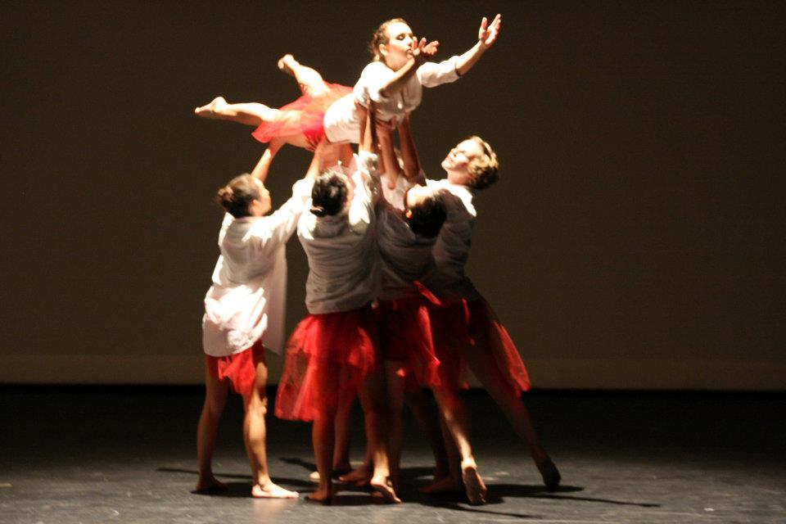
● Guest hip-hop choreographers
● Choreography strategies and projects
● Dance history
● Dance criticism
● Cultural dance appreciation

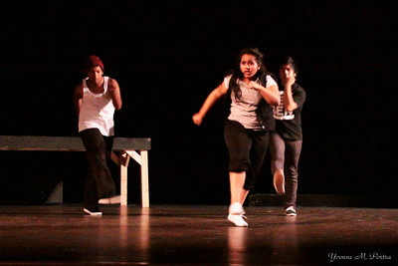
Using the California Visual and Performing Arts Standards these courses will include:
• Artistic Perception
• Creative Expression
• Historical and Cultural Context
• Aesthetic Valuing
• Connections, Relationships, and Applications

Where and when do students perform?
Our students will have in-class performances for their peers several times a year. But that’s in order to prepare for our on-stage performances in Redwood Hall (our theater), which is the main attraction! Dance One classes perform twice a year in full-evening performances (which are optional for Dance One students). Our Dance Two and Production classes perform three times a year on-stage, as well as performing in ArtsFest. ArtsFest consists of both a daytime and evening performance. The daytime performance is held outdoors during school for the student body. The evening performance is held in Redwood Hall and features all our performing arts programs.

What will my student need for class?
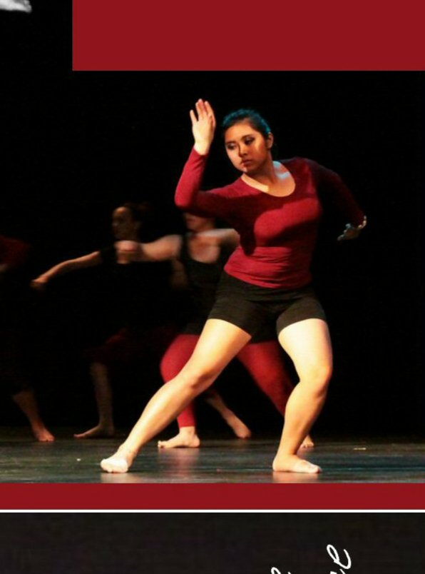
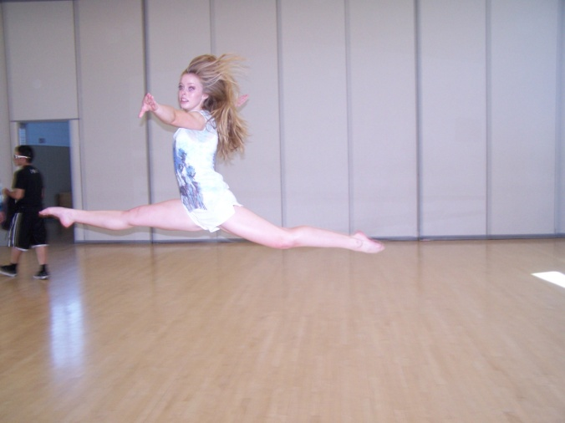
Students will need black jazz shoes, as we begin with jazz technique, and street shoes are not allowed on our hardwood dance floor. They will also be dressing out daily in ALL BLACK dance attire, which may be leggings, jazz pants, or yoga pants and a form-fitting top. No baggy clothing is permitted, as it hinders viewing the student’s body alignment and placement (which could lead to injury). Students should wear their hair back and away from their face, so a hair band should be kept in their locker at all times. A water bottle with the student’s name on it is also recommended.

